**Boolean Expressions & Logic Diagrams**

**THIS EXPERIMENT INVOLVES FORMULATING BOOLEAN EXPRESSIONS FROM PRACTICAL STATEMENTS, DESIGNING LOGIC DIAGRAMS & VERFIFYING THE SAME BY EXPERIMENT.**

1. Realize the logic diagram for the following equation and verify the DeMorgan’s law.



1. Apply the principles of DeMorgan’s theorems to the simplification of a gate circuit:

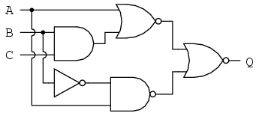

1. Represent each of the following sentences by a Boolean equation. Design a logic diagram and verify by experiment.
2. The air conditioner should be turned on iff the temperature is greater than 750 F, the time is between 8 a.m and 5 p.m and it is not a holiday.
3. The product of A and B is negative iff A is negative and B is positive or A is positive and B is negative ( use only 2 independent variables )
4. The tape drive motor should be running iff
5. The tape is properly threaded
6. An end of tape signal is not present and
7. The tape drive is in the manual mode and manual start button has been pressed *or* it is in automatic mode and a “tape-on” signal from the computer is present.
8. The sound system will squeal if the microphone is turned on *and*the microphone is too close to speaker or the volume control is set too high